Notes for debugging:

* You cannot have the CSV dump open, otherwise processing can’t save the CSV and will crash upon first write
* If the board is reset while madmapper is live, midi will stop working, restart madmapper.
* Serial output from Arduino should look like this:
* 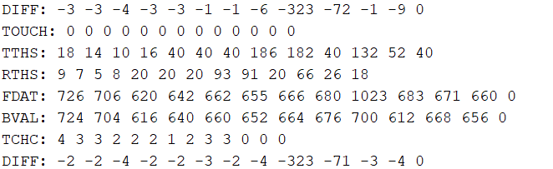
* If not(TCHC missing), MPR121 library needs to be replaced, check the folders in the github and place the MPR121 folder in users>documents>Arduino>libraries
* You will need the Midiusb library, you can download it from the Sketch>Include libraries>manage libraries… dialog and type in “Midiusb” , for sake of future proofing, version 1.0.5 was used